# Ryan Demboski

# Grouping data

The following exercises use the “supermarket” database

1. Warming up with aggregate functions: return the total price of all items in the items table and how many of them there are.

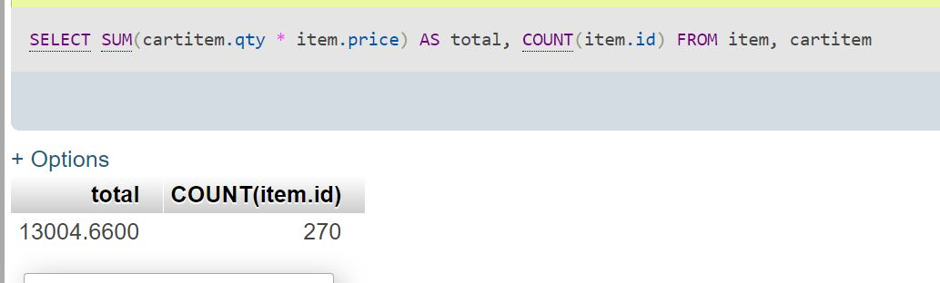

1. Return the money spent and the number of items bought per customer.

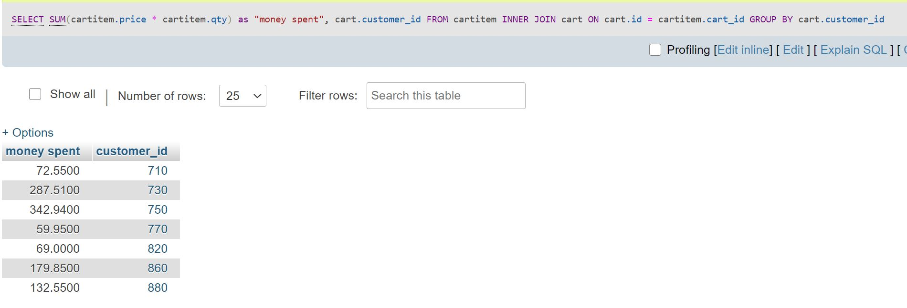

1. Similar to the last problem, but one step deeper: return the money spent and the number of items bought per customer, per cart.

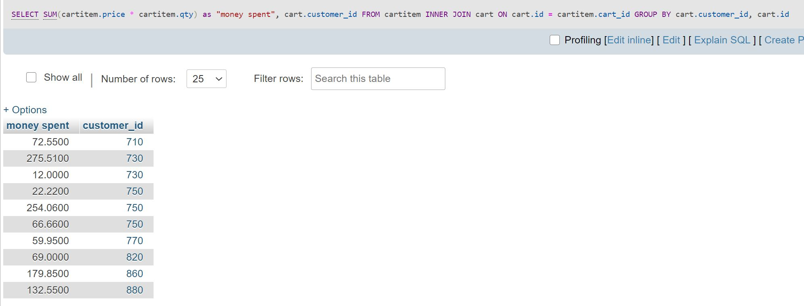

1. How many different items did each customer buy (not quantity)? Return customer name and number of different items. Hint: A. Jones bought 2 different items.  
     
   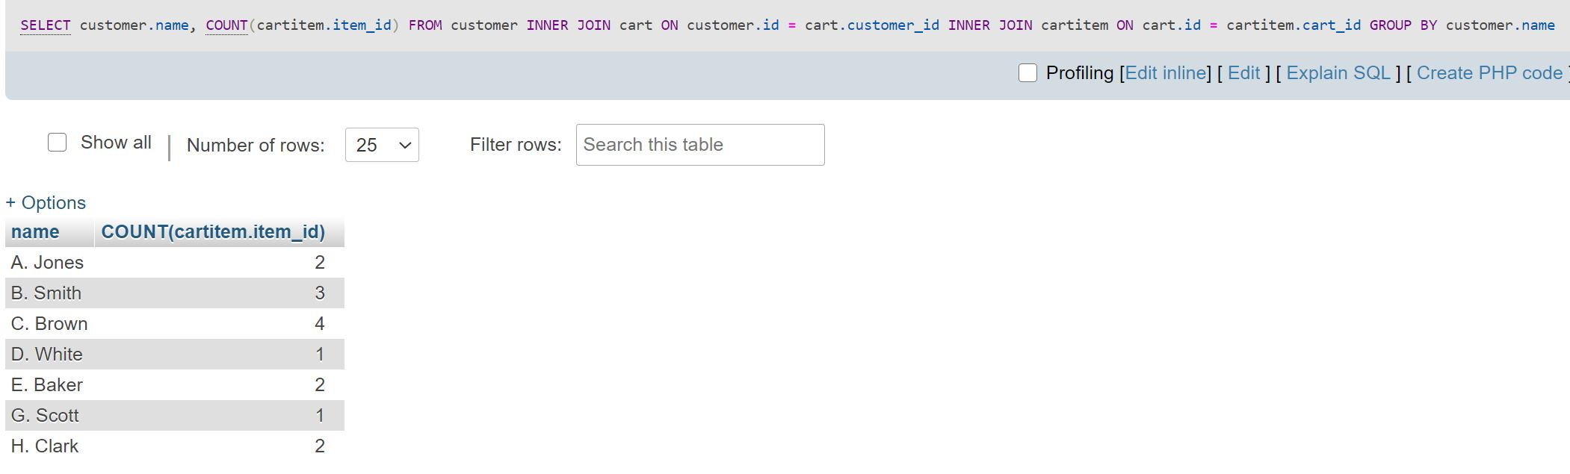
2. Get the item count of each distinct item bought per customer. Return customer name, item id and count per distinct item.  
   For example, A. Jones bought 3 items with id 5902 and 2 items with id 5913.  
   Also, you don’t need to use the keyword DISTINCT.  
     
   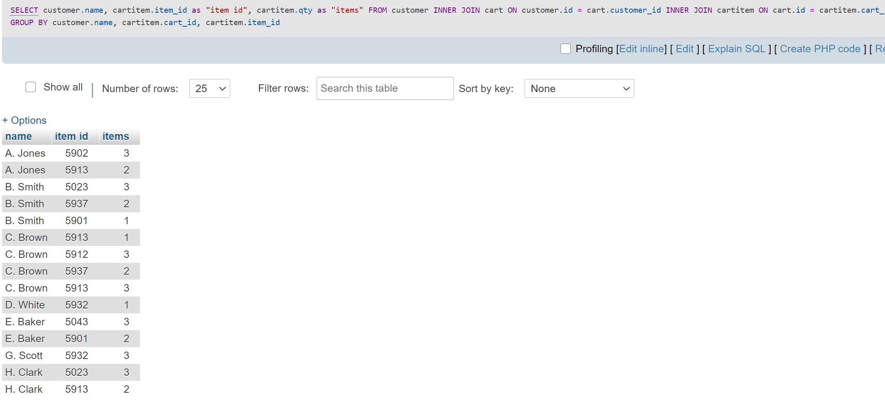
3. Return, per customer, the number of items of each distinct type.  
     
   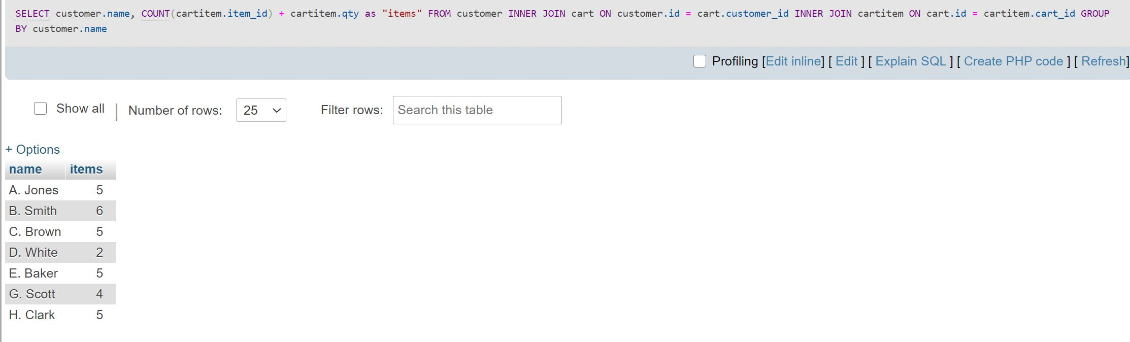
4. Per customer and per cart, get customer name, cart id, number of items in cart and the cost of all items in cart.  
     
   